EU Declaration of Conformity (DoC)

**Hereby we,**

|  |  |
| --- | --- |
| Name of manufacturer: | SPIUK Sport Line, S.L. |
| Address: | Pol. Ind. Zabale, P4C, Nave 2, 48410 OROZKO-BIZKAIA,SPAIN |
| Zip code & City: | 48410 OROZKO-BIZKAIA |
| Country: | SPAIN |
| Telephone number: | +34 902 15 72 06 |

**declare that this DoC is issued under our sole responsibility and that this product:**

|  |  |
| --- | --- |
| Product description: | Helmet for pedal cyclists and for users of skateboards and roller skates |
| Type designation(s): | SPIUK PROFIT ERT SP-17  S/M:51-56cm；M/L:56-61cm |
| Trademark: | SPIUK Sport Line, S.L. |
| Batch / Serial number: |  |
|  |  |

**Object of the declaration (further identification of the PPE allowing traceability; it may include a color image for the identification of the PPE):**

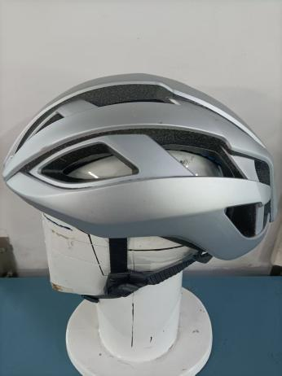

**is in conformity with the relevant Union harmonization legislation:**

**Protective Product Equipment Regulation: (EU) 2016/425**

and other Union harmonization legislation where applicable:

|  |
| --- |
|  |
|  |

**with reference to the following standards applied:**

|  |
| --- |
| EN1078:2012+A1:2012 |
|  |
|  |
|  |
|  |

**The Notified Body Kiwa NL BV., with Notified Body number 0063 performed:**

[*choose applicable Modules: B*]

**Where applicable:**

The issued EU-type examination certificate: 252310162/AA/00

The conformity assessment procedure (either conformity to type based on internal production control plus supervised product checks at random intervals (Module C2) or conformity to type based on quality assurance of the production process (module D)) under surveillance of notified body (name, number).

Additional information: (accessories)

.…………………………………………………………………………………………………………

**Signed for and on behalf of:**

OROZKO June-6th-2025 Aintzane Robles /Purchasing Manager   Place and date of issue Name, Function, signature

